OER Accessibility Series: Checking Accessibility
As you develop and curate materials, it’s important to check the accessibility on them. Luckily, the common tools we use (including websites) have easy accessibility checkers. We’ll cover Microsoft, Adobe, and the Wave Toolbar in this guide.

Table of Contents
Using the Microsoft 2019 Accessibility Checker 2
Using the Adobe Acrobat DC Accessibility Checker 3
Using the WAVE Toolbar 5

Using the Microsoft 2019 Accessibility Checker
Microsoft’s accessibility check works the same in all of its products, though each type of document has different accessibility concerns. It’s a handy tool, because it identifies accessibility issues and then tells you how to fix them.
- With your document open, click the “Review” tab on the ribbon, and then click “Check Accessibility.”
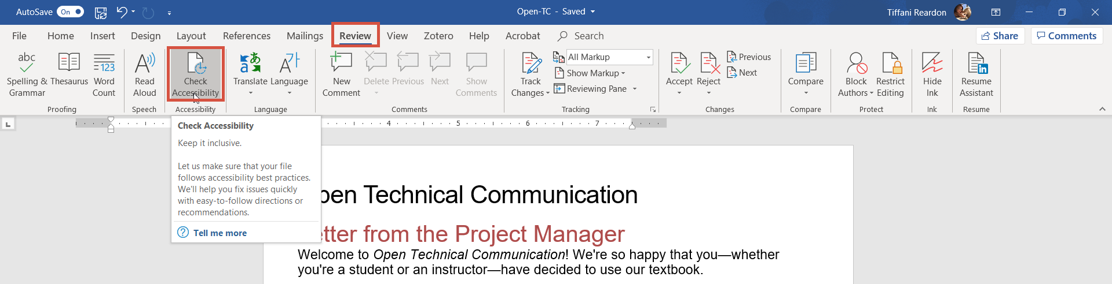

- You’ll notice a few things on the accessibility checker. There will be a list of things to look at—some may be labeled as errors and some as warnings, but you should check them all. If you click on an item, it will bring you to the spot where the error is, and it will give you an explanation of the problem and how to fix it at the bottom of the checker.
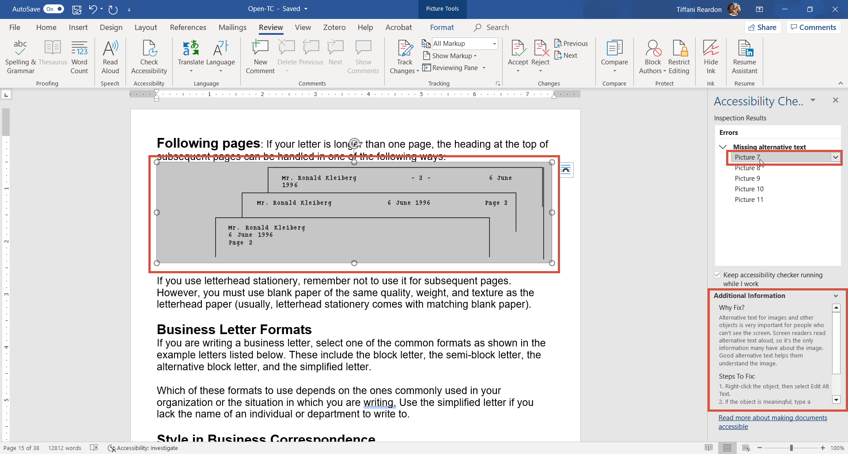

Using the Adobe Acrobat DC Accessibility Checker
Adobe has a useful accessibility checker, as well. Note that the process to make a PDF can be more complicated, so if you are creating a new document, it is better to create it in Word and leave it in Word. However, if you must use Adobe, you can still use the checker.
- With your document open, click “Tools.”
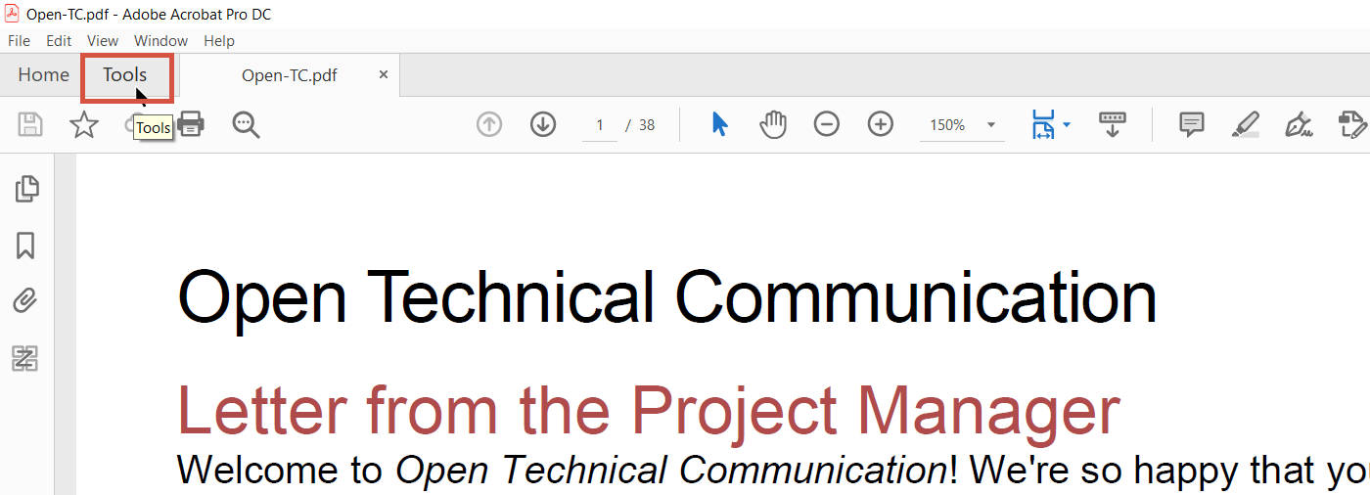

- Scroll down to “Protect and Standardize,” and then click “Accessibility.”
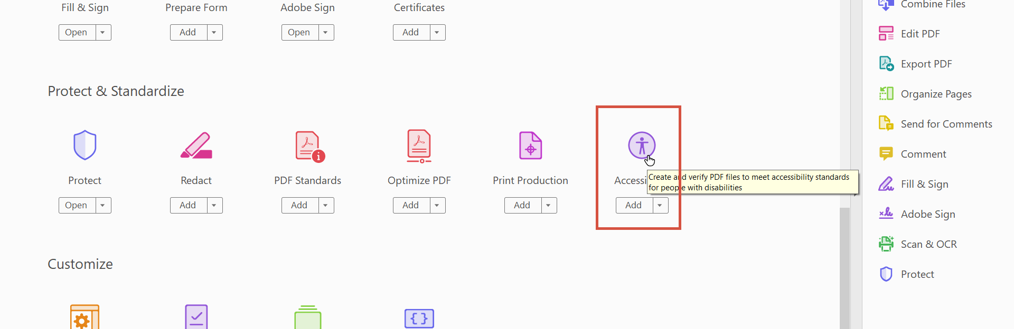

- There are many accessibility features. Click “Full Check” to check the document for issues.
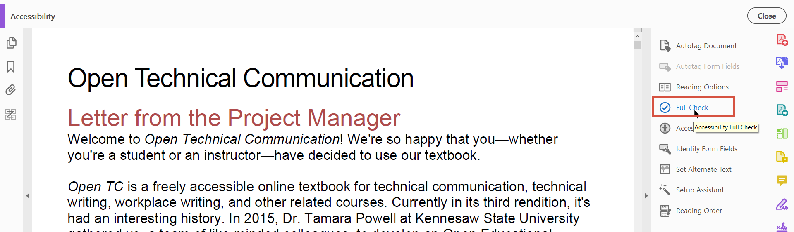

- Leave the defaults, and click “Start Checking.”
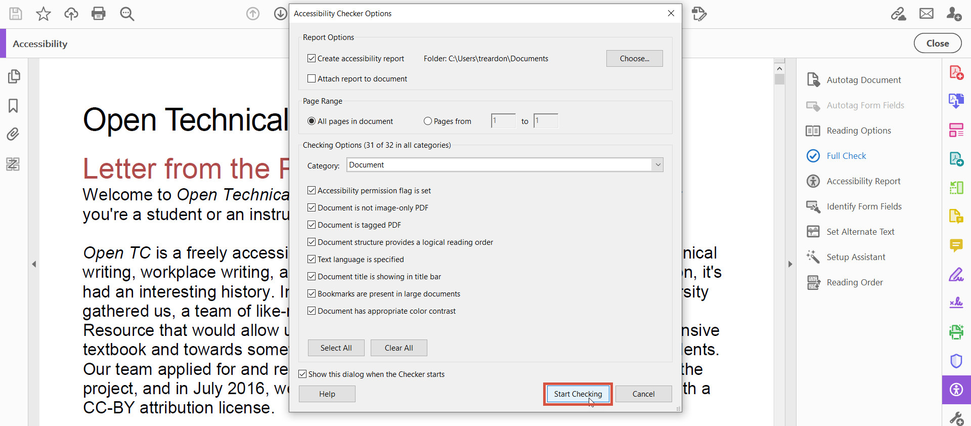

- On the left-hand side, there will be a report of accessibility issues. Click them to expand and see where the issues are. This one works similarly to the one in Microsoft—if you click on it, it will bring you to that item in the document. Some items will have a question mark next to them. Those are things that the checker can’t determine, so it’s recommending that you check it manually.
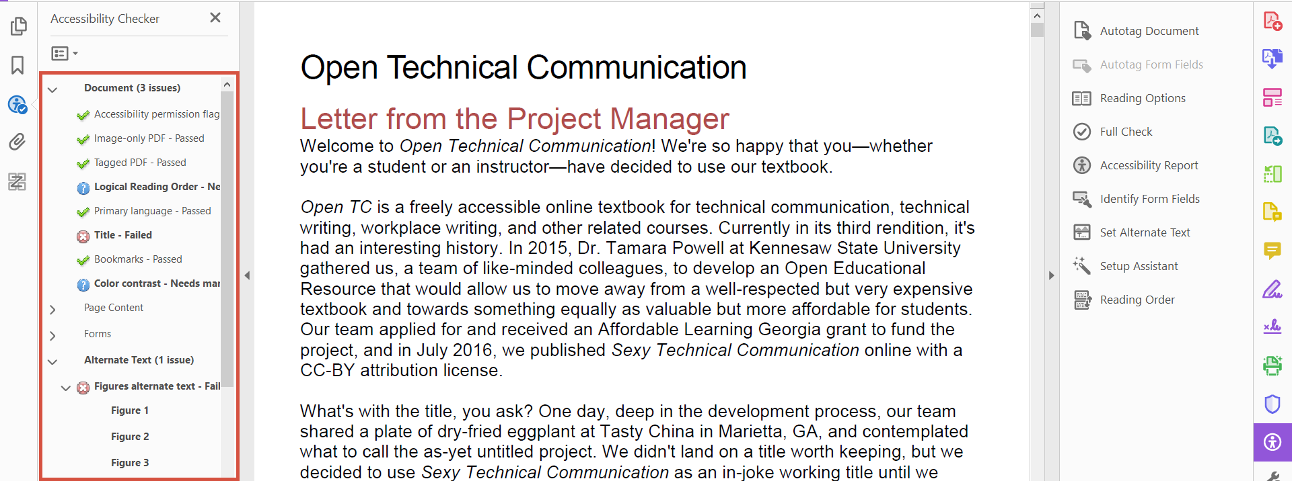

Using the WAVE Toolbar
If you are adopting materials on a website, you need to evaluate it for accessibility. Most of the time, your websites aren’t going to be 100% perfectly accessible. That doesn’t mean you can’t use it, but you do need to be aware of the accessibility issues in your websites. If it is riddled with accessibility issues, you might make the decision to find something else. However, if it is only a few small issues, you can keep that in mind and perhaps compensate for it in other resources in the course.
- Go to the WAVE Toolbar at https://wave.webaim.org/.
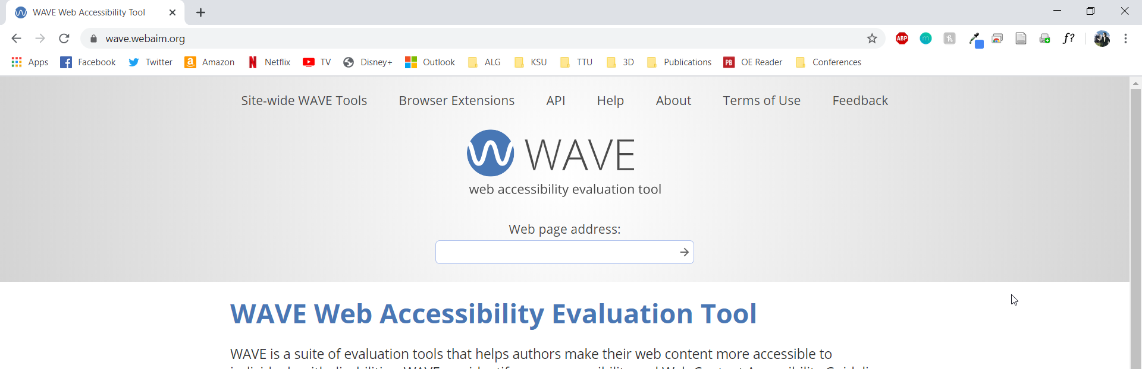

- The tool has a few options. You can install a browser extension, which will allow you to evaluate websites on the fly, or you can paste the URL into the box provided and click the go arrow. Go ahead and do that now.
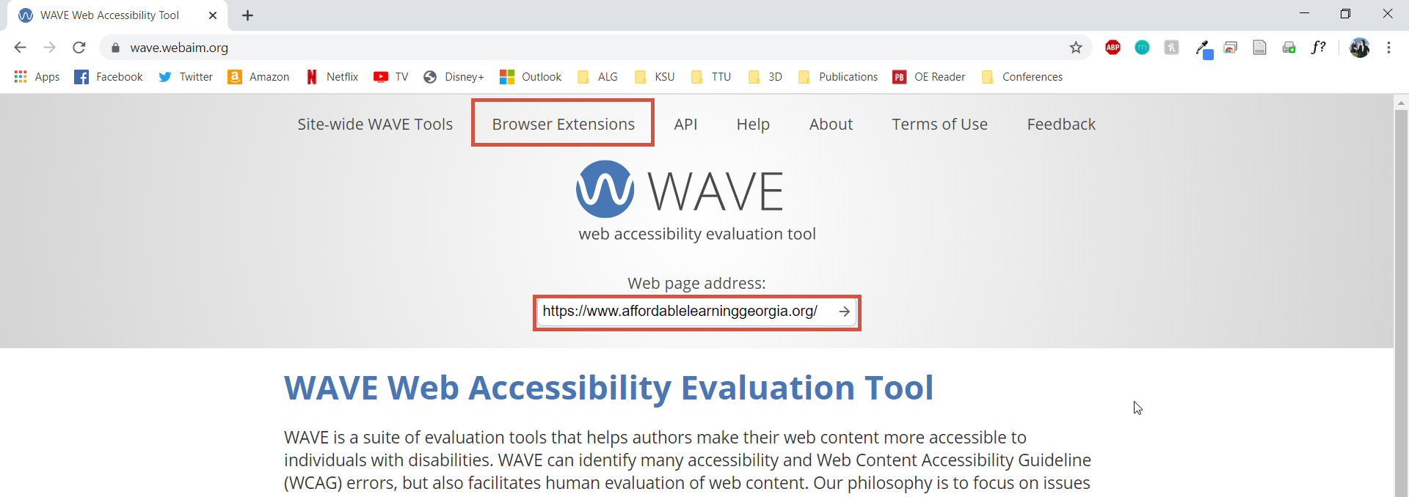

- A marked-up version of your website will be shown, as well as some information about issues on the website. To see specifics, click “View Details.”
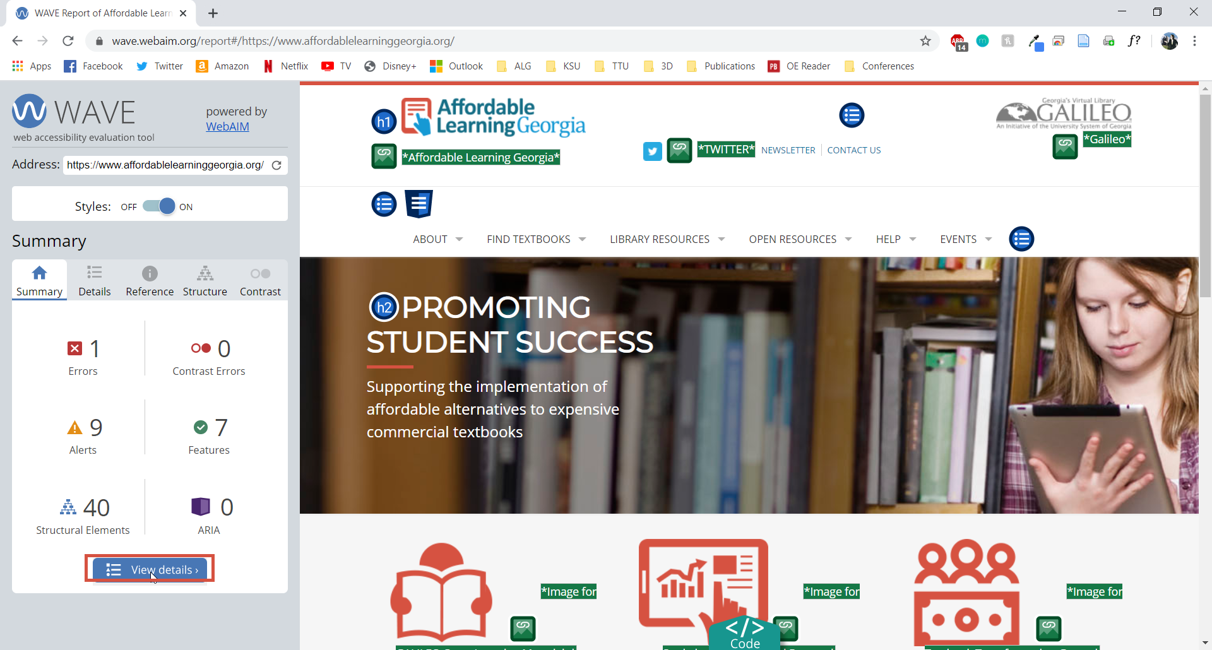

- If you click on the icons for each issue, it will highlight that issue on the page.
